Contents

* Objective
* Introduction
* Technology
* System design
* Advantage & Disadvantage
* Future Scope
* Conclusion

Object

By this project, our purpose to make framer more independent and also have a choose to compare the fertilizer & pesticide of different companies, and also compare the cost of it.

Project Formulation

In the daily operation of bus transport system, mainly that of buses, the movement of vehicles is affected by different uncertain conditions as the day progresses, such as:

* Unexpected delays
* Irregular vehicle – dispatching times
* Other incidents.

Many students are late for classes because they decide to wait for bus instead of just simply using alternate transportation.

Problem Solution

1. Focus on to providing them more convenience with bus schedules.
2. It provides Real-time bus location information so that they may not get delayed.
3. Integrated Google Maps in the application.

**Introduction**

* SUVIDHA (bus live location tracking) Application “ is an application for Smart phones Android Operating system.
* This application uses the GPS function.
* This application at a specific pickup point will send the current location of the to students when they request.
* This application at a specific prediction of bus arrivals at stops along the route.
* This application uses a varies of technologies to track the location of buses real time

**Project module**

Bus /Route

Information

Map

Location

Information

**Module 1- Location Info**

1. This module depicts the process of selection of bus no and presenting the current location of the bus.
2. Technology APPLIED:

* GPS- Global Positioning System.
* Client – Server Technology.

**GPS**

1. It is a technology where satellites send down radio signals which GPS units and receivers use to work out their current location (Which is shown by latitude, longitude and elevation).
2. GPS Works like this:
3. There are 24 working satellites circling the globe at any give moment. A GPS navigation or GPS tracker searches for the transmission signal from at least three satellites.

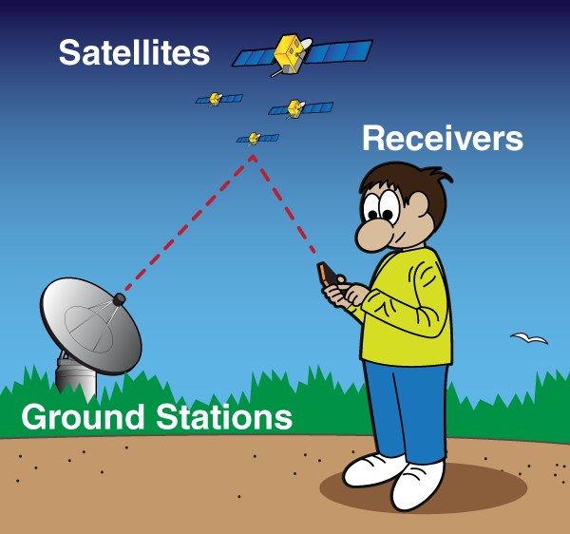

**Client – Server Working**

1. Client will ask for the location of the bus through his android device. Request to the server is made automatically.
2. Bus is equipped with GPS device.

Through GPS it will find its location and deliver it to server .

1. Server will handle the location and deliver it to the intended client.

**Module 2 – MAPS**

In this Module; application it using Google- APS to show the Maps.

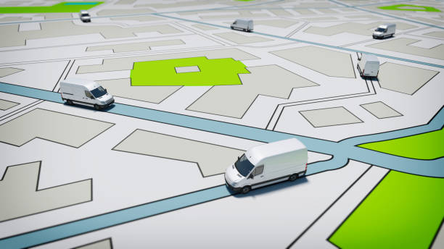

**Module – 3 Bus / Route Information**

* This Routes of all Buses are recorded by Bus in charge of college.
* For this Purpose we have used Firebase.
* Bus In – charge will update all info regarding route.
* Now when client make request for the bus information it will be fetched from the database and delivered to client through server.

**Technology**

**HARDWERE REQUREMENT**

Ram : 512 MB or higher

memory : 200MB

Processor : 1 GHz or higher

other : GPS enable

**SOFTWERE** **REQUREMENT**

* Android Studio 2021.0.1
* Java 15
* XML
* Firebase 2020.0.1

**Android Studio**

Integrated Development Environment (IDE) is used in Android development in order to make it more straight forward and quick.

It has been recommended for the developers because of its simplicity in working.

Android is basically a multitasking platform.

These Application can work simultaneously with other application because of multitasking ability of the Android platform.

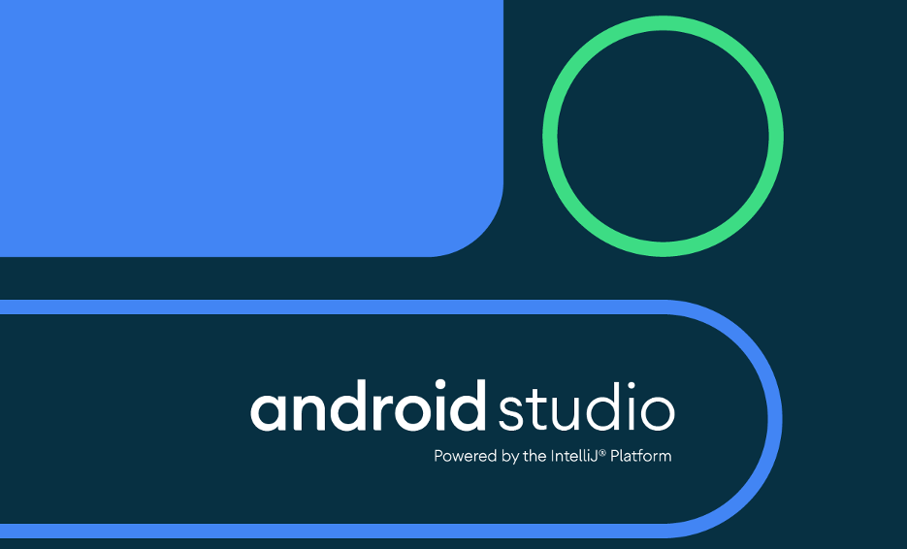

**Java**

One of the most widely used programming languages, Java is used **as the server-side language for most back-end development Projects**, including those involving big data and Android development. Java is also commonly used for desktop computing, other mobile computing, games, and numerical computing.

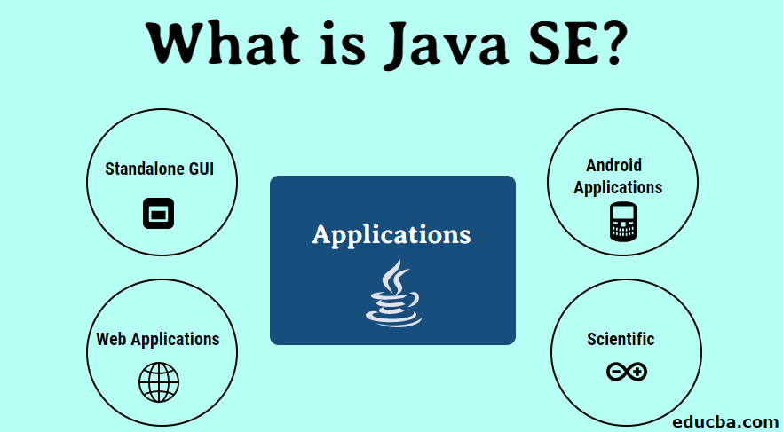

**XML**

**Extensible Markup Language** (XML) is a markup language that defines a set of rules for encoding documents in a format that is both human-readable and machine-readable. ... The design goals of XML emphasize simplicity, generality, and usability across the Internet.

**Firebase**

Firebase is a platform developed by Google for creating mobile and web applications. It was originally an independent company founded in 2011. In 2014, Google acquired the platform and it is now their flagship offering for app development.

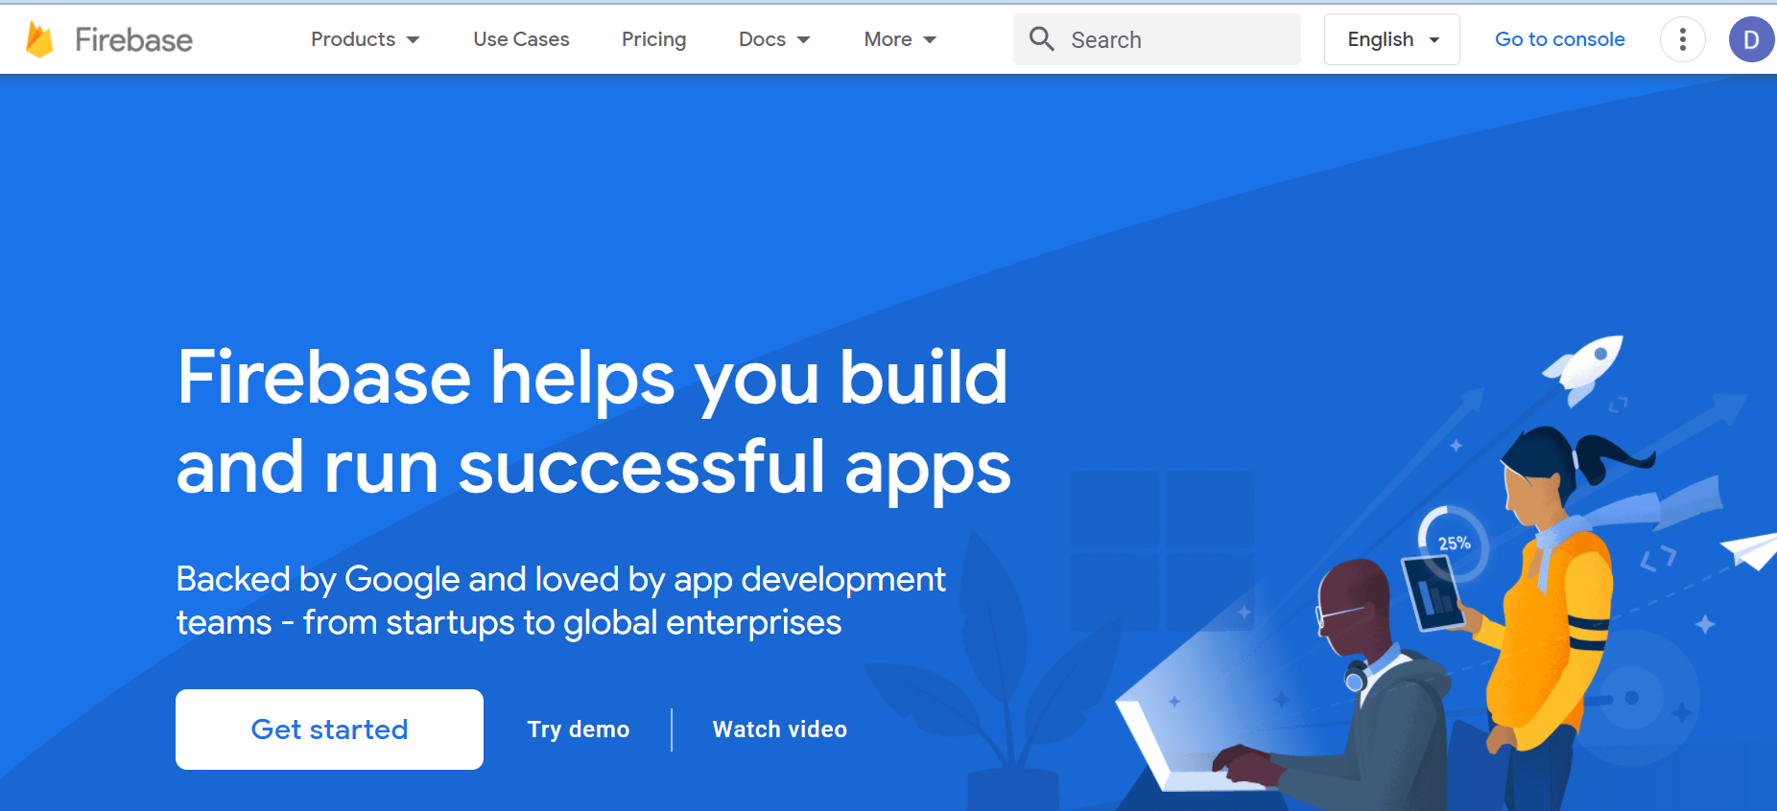

**System Design**

* **Data Flow Diagram**

**SERVER**



USER



Database

* **Use Case Diagram**











**Advantages**

* Reduces traffic in clumsy areas.
* Makes people to avoid unexpected delays.
* Improves scheduling of vehicle timing.
* Easy to catch location transports.

**Disadvantage**

GPS based location system may not work properly during inappropriate weather condition.

**Future scope**

* This Project will be put up on the cloud platform, so that it will be accessible by every Android user.
* The application will prove beneficial for every bus traveller, or even tourists. Not just buses, but this application will be useful for every person travelling by any means of transport.
* The location Tracker will give the exact location of the bus which make it essays for passengers to travel.

**CONCLUTION**

“**SUVIDHA**” (Bus Tracking Application) is an application for Smart phones that works on Android Operating system. This application uses the GPS function. This application at a specific pickup point will send the current location of the bus to user when they request. This app generate predictions of bus arrivals at stops along the route.